
Volunteer Instructions
Saturday, December 2, 2023

Event: TACA Sensitive Santa

Volunteer Shift: 8:30 AM – 2:30 PM

Date: December 2, 2022

Event Webpage: Sensitive Santa - The Autism Community in Action (tacanow.org)

Location: Anaheim First Church of the Nazarene
1340 N Candlewood St., Anaheim, CA 92805

Check-In: 8:30 AM with Nolan, Volunteer Coordinator (see map below for specific location)

Dress Code: Dress comfortable (check for the weather), anything festive is encouraged, but not mandatory.

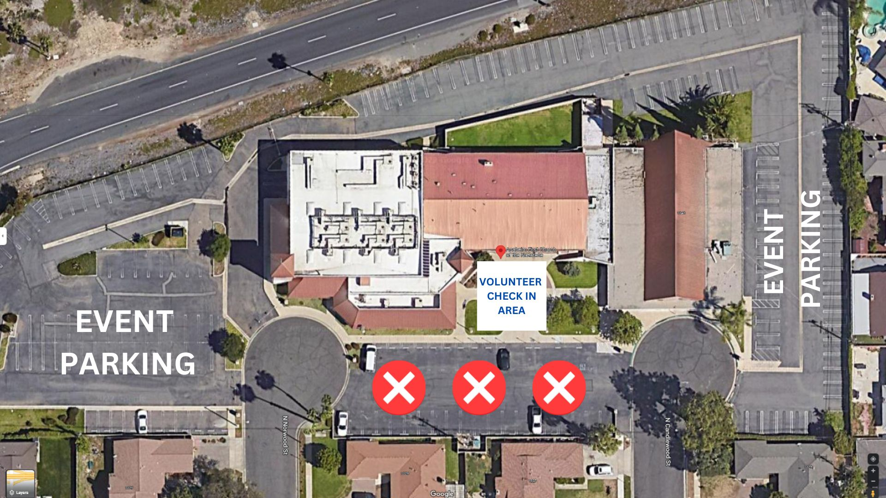
PARKING
Volunteers can come in through N Norwood St or N Candlewood St and can park around the church parking lot. The small parking lot in front of the church will be closed off for event booths.

ADDITIONAL INFORMATION
All volunteers must be at least 13 years of age and sign the attached volunteer waiver.

Lunch and drinks and will be provided for volunteers.

DAY OF EVENT CONTACTS
Nolan Thompson - Volunteer Coordinator (714) 515-9115
Carolyn Baker – Development Director (714) 469-9820

